A NEW LOOK ON THE “RADIUS OF THE CIRCLE” AND THE NUMBER “ Π “. THE MATRIX OF THE CIRCLE.
Vicențiu Dumitrescu, colonel(r) military chemical engineer, dumi1940@gmail.com

Legalized studies at B.I. Notary, according to the manuscript,
from Calea 13 Septembrie no. 103 Bucharest

ROMANIA – BUCHAREST 2020

TITLE 1. A NEW LOOK ON THE “RADIUS OF THE CIRCLE” AND THE NUMBER “ Π “.
THE MATRIX OF THE CIRCLE.
05.01.2018*
Vicențiu Dumitrescu, colonel(r) military chemical engineer, dumi1940@gmail.com

A serious error of positioning in site of some mathematical calculations, for some thousands of years, has led to an incorrect definition of the “ π “ number.
A test that Terra hasn’t passed with “summa cum laude”.
In brief:
Theorem: The Radius of the Circle – “The cast on a plan of the segment of a straight line curved in an arch of the circle, with the formation on center of an angle of 90⁰ – November 2017
$\hat{AB}$ = (π 90⁰/180⁰)·Rc $⟹$ Rc =$\hat{AB}$/0.5π
The “π” Number: a variable measure which assumes values in ratio between the tract of a curved segment in the circle arch or circle and the radius of the circle – December 2017
π $∈\hat{AB}$(ν)Lc
L. arc; Lc=(π ⁰·n⁰ /180⁰)·Rc $⟹$ (π·n⁰ /180⁰) = Larc; Lc/Rc
To n⁰=90⁰ ; 0.5 π =L arc/Rc
*On according to the computation in brackets πν (variable) = L arc: Lc/Rc; respective πν(π·n⁰/180⁰) = L arc; Lc/Rc.
* *
*
Before starting to write this material, I examined internet, the Google data base, asking the question: “What is the radius of the circle and haw to draw a circle?“
I have selected two answers that approach the subject:
- A radius is a line segment that connects the center of a circle with any point on it. Its length is marked usually by “r” or “R” – Anonymous ;
- I myself do not know and I would also like to have an answer. Does anyone of you know how to find out “The Radius in a circle?” – Anonymous/ year 2010
I have addressed the question to be connected to the latest news in the field. Obviously I have not found anything like that, but the question seams intelligent. Anonymous/year 2010
- On the Radius of the Circle and its measure; on the number “Π”.

I try to put into words the graph on the appendix plate.
The aim of the study is to bring to the level of the 21st century the definition of the Radius of the Circle as well as realizing what elements of the circle belong or not belong or may belong in the International System of Measures and Units of Measures; besides – to prevent thousands of math and computer fans to calculate/recalculate the infinite number of decimals of “π”.
From the “ Dictionary of mathematics” – Luminița Bădelniță, Ed. Danubius – I have taken over the definition of the Radius of the circle: “ the segment that connects the center with a point on the circle”.
Obviously, from this definition to what follows is a long way anyhow. That is because you think you have the circle and then take the radius – previously you need to determine the center – according to Anonymous/2010. Often you draw with the compasses the size of the radius, then you draw the circle; there are other ways too, but I do not insist. What is important is that the radius of the circle to be initial pawn in its drawing.
It is a well known fact that obeying the rule: “to draw a circle of a given radius” implies, ordinary, to select on integer number as a measure of the radius of the circle or, at best, with as few decimals, the decimal system being, partly, set right in the 8th century and generalized about the year 1500 – see the some Dictionary of Mathematics.
The main idea, I stress, is that the Radius of the circle to be a number with the fewest decimals, so that the decimals of “π” in the computation to lead to a length of the circle an integer: or a number of decimals easy to handle, according to the saying: “one nail drives out another” or “two negations lead to an affirmation”.
I will pass to the text of the drawings in the appendix.
I state that, according to their dimensions, you will read, accordingly, to the scale of Sc. 1:0200 or 1:2000.
In the first phase (Ph.1) we have, an arch of steel with L=100 cm.
In the Ph.2 this is curved in a circle arch;
In the Ph.3 we cast on the plan the said arch “$\hat{AB}$” – with the formation of an angle of 90⁰ – to see the new definition of the Radius of the circle on the first page.
In the Ph.4 – more complex – the calculation in meters of the Radius of the circle (a1= 63.6619… m), as well as the part of the segment of line that “virtually” did not curve: a2 – that is for a future comparison with the graph in Ph.1 – formulae and computation – following.
I stress that the data have been calculated with the software of the cell – telephone Sony Xperia M5, that allows up to 15 decimals.
From the formula $\hat{AB}$(or L.arc)=(π·90⁰/180⁰)·Rc we withdraw Rc (the Radius of the circle), $\hat{AB}$ being equal to 100 cm, thus Rc=100/0.5·π; Rc=63.66197725 m, and 0.5·π having the value of 1.570796326 cm/m on the trace of the arch of the circle.
The same result is given by the ratio Lc(400m)= (2π)·Rc $⟹$ Rc=400/2·π.
I assume that I preserve, largely, the dimensions of the elements of the circle and the marks in the studies published in the previous issues of the journal. Most frequently the calculations with the cancelling of the decimals in the 9th position (here – “6”) are sufficient. The part which “virtually” does not curve would have the value of:
a2 = 100 – 63.6619…; a2 = 36.338022764 m.
Obviously the diameter of the circle (dc)≡2·Rc; dc = 127.323954473 m that is like a nostalgic retrospection.
We also calculate 4a2= 154.647908944 m, where we notice that: 4a2 > dc – that is to compare the given situation of F.1” that will follow.
We go on with a matter which should not be avoided. We state that a radius “cast on a plan” in the segment of the line curved, with the value of 63.6619…m draws an arch of circle with the length of 100 m. That is as if the space would expand (I do not approach the problem of the Radian). Each cm/m of the Radius of the circle, I again stress, would correspond to 1.570796326 cm/m on the tract. It is to be taken into account as it could be used to the choice of the dimension of the Radius of the circle/the length of the circumference of the circle, etc.
Thus, π/2 becomes the new constant, equal to the ratio of Larch, Lc and their projection in plan
We also consider, from the above mentioned statements as well as in the sequence of the first formula, that “π” belongs to the tract of the circle arches, that is the circumference of the circle, according to the its four quadrants (indicated, this time, counterclockwise – for an easier drawing of the semicircle) I – IV – see Ph.5; circle “C”, the appendix plate – its value (of π) evolving growing thus:
- In the I quadrant:
$\hat{AB}$ = Rc ·π/2, resume = 1.570796326…
- To the first semicircle – B.G. we get 0.5·Lc = π·Rc $⟹$ π = 3.141592653…(the classic π)
At the end of the Third quadrant we get:
- 3/4·Lc = 1.5·π·Rc; respectively $\hat{BC}$ = π·(270⁰/280⁰)·Rc, where $\hat{BE}$ = 300m. Thus 1.5·π = 4.712388980.. and, finally, in the IV quadrant we have:
- Lc(400m) = (π·360⁰/180⁰)·Rc $⟹$ 2·π = 6.283185306…

We draw the conclusion that the circle arches, with endings in certain points on the track of the circle length, can be easily determine, thus facilitating the value of “π”.
Within this context, we can introduce the concept of “variable π”, with the symbol “πν” and the segment of the formula (π·n⁰/180⁰) may be replace by “πν”, the classic formula being: Larch; Lc = πν·Rc. We thus avoid computations that might contradict the rational of the present study.
Thus, at the end of each circle arch, corresponding to the four quadrants (I - IV) the formula becomes:
- L arch (100cm) = πν·Rc (63.66297725 cm) $⟹$ πν = 1.570796326…; from the classic π (π·90⁰/180⁰)·
For the following quadrants the calculations are similar.
Checking operations:
πν(1.570796326) = L arch/Rc (1.570796326)
I am going to emphasize the quadrants I – II in connection to the determination of “π” (classic; 3.141592653….)
This time let us take a segment of steel with L = 200 cm. We curve it as a semicircle and cast it on a plan. This is nothing else but the diameter, with the length of two circle radii, that is 127.3239545 cm, according to the well known calculations.
L sc(semicircle) 200 cm = π·180⁰/180⁰·Rc(63.66197725 cm) $⟹$ π = 200/63.66197725; so π = 3.141592653…
It is quite clear that the classic π is not the ratio between Lc/dc, but the ratio between L arch; Lc/Rc; Lc =/= dc·π
Where is the error in my opinion?
Let us resume the calculations in the formula:
L arch(100 cm) = π·90⁰/180⁰·Rc quadrant I
And make the necessary simplification: 90⁰/180⁰ = ½
L arch = π·Rc/2 $⟹$ 100 cm = 3.141592653 x 63.66197725cm/2
Further on: 200 cm (from 100x2) = 200 cm. Now I enquire:
“Where from this 200 cm, when, actually, we are in the I quadrant of the circle, where L arch = 100 cm?”
In the Note to the present study, L arch 100 cm = (π/2)·63.66197725; 0.5·π being just 1.570796326.. or πν = 1.570796326… avoiding the ratio 1/2·π = 1.570796326….
Let us try two more tests in order to realize more about the matter, according to the new view.
- Let us have Lc = 400 cm, and the angle to the center 195⁰.
To find out the other parameters of the circle, respective πν and Rc.
From the very beginning we consider that we operate in the III quadrant L arch = (π·195⁰/180⁰)·Rc or simply L arch= $\frac{Lc(400cm)·{195}^{0}}{{360}^{0}}$
L arch = 216.66666666… cm and πν = (π·195⁰/180⁰);
πν = π·1.083333333 $⟹$ πν =3.40339204, and
Rc = L arch/ πν; Rc = 216.666666666…../3.40339204 and finally, Rc = 63.66197726…cm
Checking
πν (3.40339204) = L arch/Rc(3.40339204)
We summarize that, without referring to the function relations, to monograms, to computer programs and others, the results are not hard to find out.

- Let us see how the computation run when we operate in the first part of the quadrant I with the final result of a subunit πν – addition of January, 10/2018.
Initial data:
n = 1⁰; Lc = 400 cm, and Rc = 63.66197725 cm.
  - We have: L arch = (1⁰/180⁰·π)·Rc $⟹$
  - We substitute the segment of the formula (1⁰/180⁰·π) with π_{ν}, doing, first the respective calculations (π/180⁰) = 0.017453292. Thus,
  - πν ·(0.017453292) = L arch/Rc·(63.66197725)
a simple way of finding L arch is:
  - L arch = 400 cm/360⁰; L arch = 1.111111111 cm (corresponding to $\text{∢}$ 1⁰)
  - We fill the determined data into the relation:
πν = L arch/Rc; πν·(0.017453292) = 1.111111111/ 63.66197725 $⟹$ πν(0.017453292) = L arch/Rc(0.017453292).
Note: πν shows as subunitary: 0.0174533292 or (1.7453292)·10⁻²
Checking:
- to $\text{∢}$ 360⁰; πν = 360⁰·0.17453292 $⟹$ πν = (2π classic)=6.283185306;
- to L arch (1.111111111 cm)x n(360⁰) = Lc 400 cm.
thus, Lc (400 cm) = Lc (400 cm);
- According to the calculations in the 2.5
πν·(1.7453292)·10⁻² = (1.7453292)·10⁻²
and many other applications may be done.
Also S_{O} = πν·$R_{O}^{2}$; where in the end πν =L sc/Rc
- Other details regarding the matrix of the circle.

Besides those mentioned earlier, let us consider a simple formula which can give a radius of the circle with an integer number followed by decimals, with the view to easily approach the meter of the circle – see Phase 1 – Plan.
L arch$\hat{A^{'}B^{'}}$ = (2/3Rc)·0.5·π – quadrant I
We introduced in the formula, for example, the 2/3 fraction. Initially Rc = 100m
We calculate:$\hat{A^{'}B^{'}}$ = 66.666666666 x 1.570796326; $\hat{A^{'}B^{'}}$= 104.719755118 m.
Obviously the radius of circle has drawn an arch of circle of a higher dimension than the previous case. Nevertheless, situations occur in which, with all the 2/3 fraction to reach the radius of the circle as an integer number (e.g. 0.666666666…x 1.5 = 1.0)
To have in mind that the line segment that is curved belongs to the metric system. Thus, there is a good agreement in calculating the elements of the circle, thus: 4a2’ = 4 x 33.333333333 cm/m; 4a2’ = 133.333333333 cm/m, where 4a2’ = dc (the diameter of the circle) in contrast to the first case where 4a2 > dc (the circle in fig. “C” - Plan).
The decimals of the different numbers can be managed more easily if they are truncated and adjusted, as presented in the Military Chemistry Magazine of the Reserve and Retirement Military Chemistry nr.11 December 2016 and nr.12 May 2017.
Do not end before mentioning two issues:
- I picked up the numbers π, but woke up in time
- As a corollary of those thought out and written between May 2014 and December 2017 – “The straight line has done its duty”

* *
*

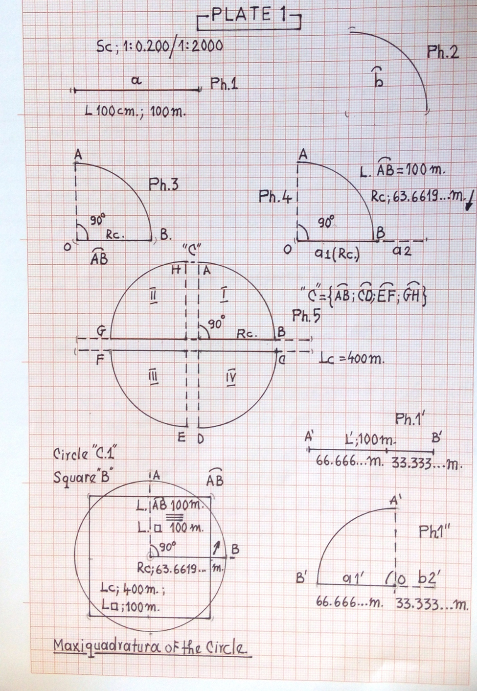

On π and π in the Peoples’ Cultures
Addition of 10.01.2018
The oldest value of π was given by Ahmes, the Egyptian, about 1800 B.C. = 3.1604; Archimedes
Stated that π represents the perimeter of the circle (perimetros = outskirts) - C. 287 – 212 B.C. The ratio of any circumference and its diameter is lesser than 3·1/7 but grater than 3·10/71 (my note 3.142857142….> Lc/dc > 3.140845070…)
In the year 1400, the Uzbec scholar Djemsid Ben calculated “π” using a regular polygon with over 800.000 sides = with 16 decimals: 3.1415926535897932 = a surprisingly exact result.
The Dutch mathematician Ludolph von Keulsen (1540-1610) of Leyda, in the year 1596 got the value of “π”with 35 decimals, the number carved on this tombstone (the Ludolphian number): …3846 2643 3832 7950 288 (35 decimals).
Nowadays with the value of 3.1415… π was first used by W. Jones (1675-1749) and came to the general use due to the Swiss mathematician L. Euler (1707-1783).
The English mathematician William Shaks, at the end of the 19th century, using paper and pencil, calculated 700 decimals of π, only that after the invention of the computer in 1945, it was found out that the 528th decimal was wrong and, consequently all other ones that followed were obviously wrong.
In the last half of the century a real competition was held among outstanding mathematicians and computer scientists in calculating more decimals of π. The French mathematician Fabrice Bellard – over 2.6 billion decimals and the Japanese research Yasumara Kanada – 51 billion decimals.

Application of π

The calculation of the circumference of a circle requires, theoretically, less than 12 exact decimals. For example, a value reduced to 11 decimals is precise enough to calculate the circumference of the circle of the Earth size with a precision of 1 mm, and one with 39 exact decimals is enough to calculate the circumference of on circle that is contained in the observable universe with a precision compared to the dimension of an atom of hydrogen.

“π” in the peoples cultures

The Congres of the United States, with about 25 years ago, declared the day of March, 13 (3/14) in the American calendar as the “π” Day.
This date is also celebrated in the Anglo-Saxon countries, as well as in other states.
- From the data-base of Google.
- Luminița Bădelniță, “ Dictionary of mathematics” – Ed. Danubius.

TITLE 2. THE Π CONSTANT AND THE SEMICONSTANTS Π/2 AND Πv/2 OF THE CIRCLE. THE 3 D IMAGES IN THE FIELD OF THE CIRCLE
22.02.2019*

The present episode is a sequence of the material in the Review of Military Chemistry no. 14 anniversary / Mai 2018.
The field extents, studying the work, consider that they have realized that there have been several directions of analysis; but only two are important – one refers, obviously to the classic ”π” number (3,141592653…) and “πν” (π variable) and the second to the new constant “π/2” and “πν/2”(1,5707963265…) of the circle, and hence called the semiconstants of the circle.
The semiconstants, as they are taken from the numerical value of “π” and are considered as a continuation of that, and their variability rests in the fact that they can be found under various types.
As I hadn’t got into details in the previous number of the review, I am going to do it here.
- The “π” classic constant of the circle

From the graphic of the Plate no 1 the difference among the three elements of the circle will be revealed, the semiconstants and “πν” or classic “π”.
It is well known that “π” is an irrational number (Q): 3,141592653…, and the fact that it is considered a constant of their geometric figure, it refers to the ratio between various dimensions of the circumference of several circles and their diameters (“π” = nLc/ndc) Fig. 1 with the circles: C₁, C₂ and C₃.
To C₁ we have “π”=Lc (the length of the circumference of the circle) of 314,1592653cm /dc (diameter of the circle) of 100cm; $⟹$ “π”= 3,141592653
To C₂ and C₃ – with dimensions – see the plate – the result of the mathematic calculations will be identical.
Thus, the classic “π” refers to that.
Before going to the semiconstants of the circle, some words and examples on the ever decimals of “π”.

- The nine decimals of the “π”

In approaching this matter, we have to take into account a sort of “assumption”. “Of the numerical value of “π”; 2π; $\sqrt{π}$ ; and π/2” and of certain formulae of the circle we are going to employ further on…”
It is the matter of the first nine decimals: 3,141592653 of the respective specifications.
“Why the first nine decimals are, usually, sufficient?”
Because they induce a reasonable number of decimals in the other terms of any mathematical relations, we operate with, to satisfy the result.
It is steadfast that we have in view that number 9 (nine) symbolizes the indices of identifying our Terra by tertiaries in the intergalactic space.
Maybe that might be the cause of the expected results.
I am going to detail three examples to the formula “Lc= 2πν·Rc”
- The radius of the circle – as an integer number;
- The length of the circle – as an integer number;
- All the three members of the mathematical relations are decimals.
- Initial data;
a₁. The Radius ʘ of the Sun: ~ 69,050 km – as an integer;
a₂. Lsc_{ʘ} (the length of the solar semicronn) = πν (3.141592653) x Rʘ (696050) $⟹$ Lsc ʘ ~ 2,186,705.56612065 km.
a₃. Checking: Lsc ʘ/ Rʘ = πν (3.141592653!) or
- Initial data:
b₁. The Length of the circle; Lc=400m – as an integer;
b₂. 2πν = 6.283185306*
b₃. Rc =Lc/2” πν”; Rc=400/6,283185306; $⟹$Rc=63,66197724870984 m
b₄.Checking up: Rc·2·πν=400! Thus 400=400!
*”Artificial intelligence” to be taken into account (of the computer)

- All terms of the math formula of the circle an of the “Q” type:
Lc = 2 πνRc
c₁. Lc = 25,123456789012m (12 decimals);
2πν = 6,283185306;
Rc = 3,998522336277567m (15 decimals)
c_{2.} Checking up: 2 πν =Lc/Rc $⟹$ 2πν=6,28318506000000!!

- Semiconstants “π/2” and “πν/2” of the circle

Semiconstant (sk) “π/2” – is the ratio between a straight line segment curved in a demicircle or circle and its projection on a plane, respectively the (virtual) diameter overcast* as the circle Fig.3/Plane 2
*To the projection of a circle on a plane we deal with two diameters superimposed – type “3D image” and not only one.
Semiconstant (sk ) “πν/2”. The definition is similar to the radius of the circle, only that in this case, we take into account the longer or shorter dimensions of the straight line segments, curved in an arch of the circle. Fig. 2.3/ Plate 1, as well as The Review of the association nr. 14/2018, pg. 126 and 161.
Both semiconstants of the circle have the same numerical value (1,5707963265…) and they can be found in several situations (determinations). A better mark for sk, “π/2” which further conveys the numerical value of “π”.
There is a distinction between the theory of “πν” and definition sk, “π/2” – as we are going to see further.

C.1 The Semiconstant “π/2” of the circle
The situation I.C.1

There is the straight line segment AD(157,07963265 cm) – Fig. 2.1/ Plate 1, curved in a semicircle – Fig. 2.2 whose projection on a plane is identical with one of the diameter of the circle – marked d’sc and equal to 100 cm.
To these data we apply the basic, classic formula, which we simplify:
Lc=dc· π/2 |:2 $⟹$ dc = Lsc (the length of the semicircle): π/2, but dc≡d’sc;
and π/2 =Lsc (157,07963265):d’sc (100cm);
thus, as a proof: π/2(1.5707963265)= π/2(1,5707963265)

The situation I.C.2

According to any segment of a circle “cut” of the circumference – Fig. 2.4; 2.5/Plate 1 brought first to the semicircle from and cast on a plane.
The same calculation formula is applied as to I.C.1., the dimensions of the “cuts” being from the largest to the integer values.
Example:
Let’s take Lsc=0,01 mm;
We take the diameter of the circle also from the formula dc=Lc/ π
dc= 0,02/3.141592653; dc=0,006366197724870 mm
We simplify the relation, idem I.C.1. respectively:
Lsc(0,01mm) = dc(0,006366197724870 mm)·π/2;
And again dc≡d’sc
$⟹$ “π/2”= 0,01/0,006366197724870
Finally: ”π/2”( 1,5707963265)= “π/2”(1,5707963265) as a check of the calculation
As we have mentioned before.

- From “πν”(π variable) to “π/2” and viceversa
“πν” $\vec{←}$“π/2”
To “πν”
D.1. Initial data:
Lsc=157,07963256 cm; dc=100cm; $⟹$ “π/2”= 157,07963265/100; “π/2”=1,5707963265;
We simplify reduce the basic relation Lc=2πν·Rc|:2 $⟹$ πν=Lsc/Rc; to Rc=50cm.
“πν”=157,07963265/50; πν=3,141592653;
Thus, πν(3,141592653) > π/2(1,5707963265) as a numerical value.
” πν” stands here according to the definition – the radius of the circle extends to the point “D” (from “A”) with the formation on the center of an angle of 180⁰;
We fill in the data in the formula:
πν(180⁰/180⁰·π)=Lsc (157,07963265cm):Rc(50cm)$⟹$ πν(3,141593653)= πν(3,141592653)

To π/2
D.2. – We employ the same geometrical figure – Fig. 2.2 Plate 1 and the same numerical value
We reach “π/2” having the foundation – we know mow the projection on a plane of the semicircle ‘AD’ – according to the exemplification from I.C.1. Thus , π/2˂ πν as a numerical value; with examples to D.2.1.
D.2.1. – We have in view the relation “π/2” = Lsc/d’c according date also Fig.2.2 $⟹$ π/2=157,07963265/100; π/2=1,5707963265;
And we know that “πν” in the “D” point =Lsc/Rc;
Substituting the data we get:
“π/2”(1.5707963265) ˂ “πν”(157,07963265/50)
Finally:
“π/2”(1,5707963265) ˂ “πν”(3,141592653) also as a numerical value.

- “3D” images in the field of the circle

It is well known that one of the definitions of the circles states that it is – “a curved closed line”.
There is a definition, but I am not aware that anyone should have put it into the good use to start the construction of this geometric figure from “a straight line”, or “a line segment”, as then he would have realized that the circle implies several subtleties more than it appears at first sight and that can generate new math relations or segments of math relations.
Several considerations and determinations should be taken into account:
- The circle specifies are easier revieled when we start from a straight line/segment of a line, followed by their curving in a circle arch/ circle segment until the whole circle – Fig. 2.1; 2.2/Plate 1 and Fig. 3/Plate 2.
- The geometric figures attract by themselves, as we have mentioned already, new math relations – according to the working cuts show to the circle radius; πν (variable π); the semiconstants π of the circle a.s.o.
- To the construction of the circle, you should have noticed that, at first, you strike a semicircle, than a second one, both completing the circle, but letting the trace of the projections on a plane (be it virtual – as a 3D image) – the projection represents but the diameters superimposed of the respective semicircles – marked by d’c and d”c on the plates.
- To be remembered is the fact that each semicircle has its own “πν”(3,141592653) in the point “G” and “C”, with a total of 2”πν”(6,283185306). In calculating, as a rule, we have cut the number “π” after the 9-th decimal – see the recommendation to the letter “B”.

E.1. The problematization of the projection on a plane we had detailed before, so that I would not insist – Fig. 3/Plate 2.
E.2. An application of the “superimposed diameters” resides in Fig.4/Plate 2 with superimposed points B; C(0⁰;360⁰) and G; F (180⁰;180⁰) – explanation to Plate 2.1.

- The Map of the Time Zones
Both determinations in Fig. 3,4/Plate 2 are considered in Plate 2.1.
“The map of the time zones” – printed after the School Geography Atlas – a selection

***
I won’t close this episode before mentioning two matters.

- – A True Story
A saying: “ After the war, many heroes emerge”.

To the question “How was that possible “ That for thousands of years, mankind be in a confusion towards the real definition of “π” number?
The first answer of myself would be: “due to the definition and the mathematic relation, almost perfect, related to the “π” number: Lc=dc·π; almost perfect, as by an yes/no answer we have to choose “no” – no details…..
The second answer I choose to give by the same truncated question: “How was it possible?”
“How was it possible that the official time of the earthquake of 27/28 October 2018 to be recorded at 03:38 instead of 02:38?
It was the evening/night of passing from the summer hour to the winter hour. At 02:40 I switched on my TV. No television channel gave information on the unwanted event for about ten minutes when I zapped the channels and let the set functioning.
But on the morning of the 28th October, “several heroes emerged” on the TV channels with different suggestion and opinions…
A similar thing, probably, happened concerning the “π” number!
Testing: What time was it when the earthquake of October, 28, 2018, happened?

02:38
03:38

- Sending a message…..
I sent to a dignitary, out of respect, on October, 22nd 2018, the Review of the association no 14/2018 that included the study of myself on the new view on the radius of the circle and the ”π” number.
I quote the last but one paragraph:
“I have in view to demonstrate 2+1 these/ideas*, after which we will be able to talk about the raising of the I.Q. of the Earth to the standards of the most intelligent planets of the Great Universe in the fields approached”.
I haven’t got an answer until today – 20.02.2019 – at least of acknowledgement !?

*It is about the episode of the present article.

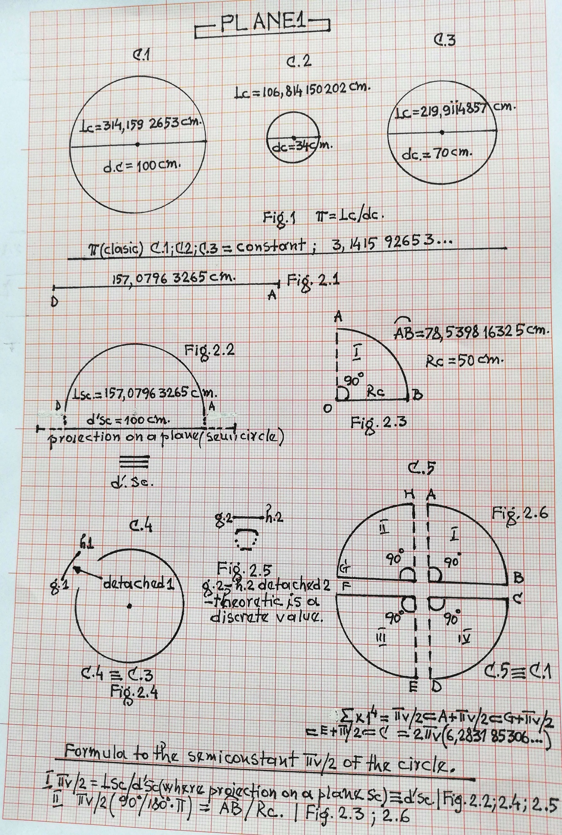

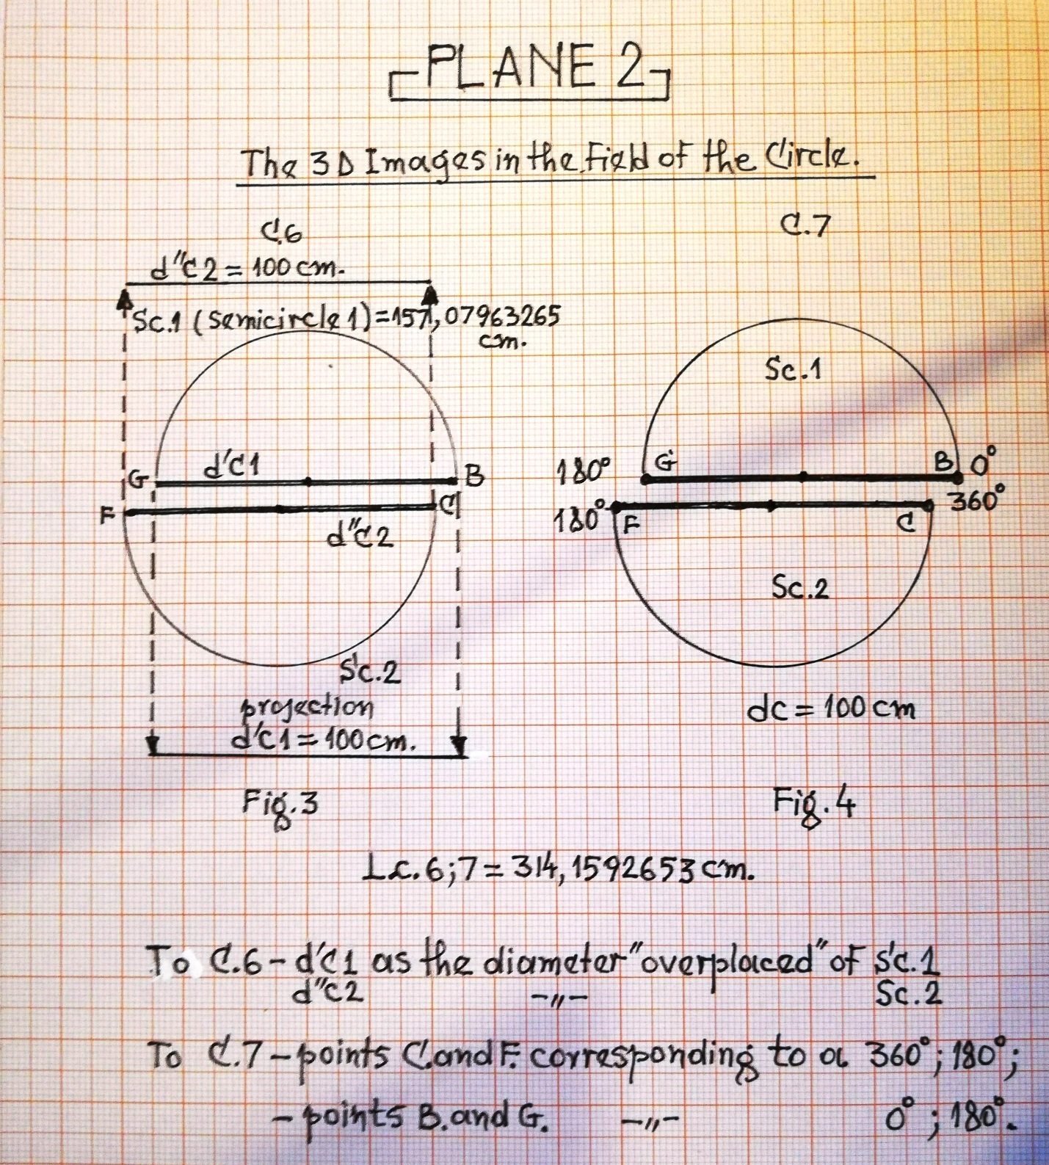

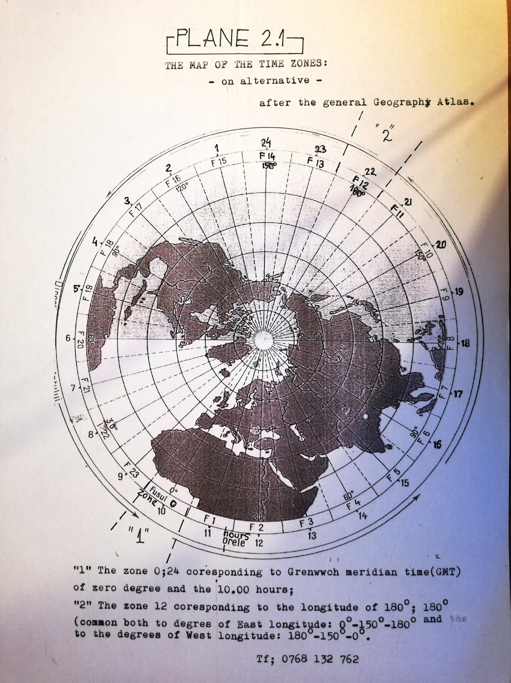

TITLE 3. THE "MARGINALIZATION" OF THE CLASSICAL "Π" NUMBER. FOLLOW-UP TO THE STUDY "A NEW VISION ON THE RADIUS OF THE CIRCLE AND THE NUMBER "Π". CIRCLE METRICS ”
13.02.2020*

In a way, the marginalization of the classic “π” number; it is only a question of the mathematical symbol, since the afferent numerical values ​​continue on, as I have previously stated.
The problem is to answer a series of questions;

- ” With what mathematical symbol can the millennial “π” be replaced, with the imperative to correspond to the same numerical values = 3,141592653....; 1,5707963265....?”
- ” What is the geometric figure associated with this idea?”
last but not least,
- "Which segment of mathematical formula or rational fraction can be used?"
Well...! There is an answer to these questions, if we consider the correlation of data from the second episode of the study, regarding the constant “π” and the semiconstants of the Circle, with the first episode, about the New Vision on the Radius of the Circle and the number “π”.
For a more accessible understanding of the problem, I initially reproduce some mathematical formulas, with the graphics of the geometric figures inserted in the two works; then, the formulas, with the necessary updating;

- The formula for the new definition of the Radius of the Circle;
$$\hat{AB}=\left(π∙\frac{{90}^{0}}{{180}^{0}}\right)∙Rc\underset{⇒}{} Rc= \hat{AB}/0,5∙π$$
- The formula regarding the new vision on the Number “$π$”, respectively “$π$v” (variable $π$);
$$πv∙\left(π∙\frac{n^{0}}{{180}^{0}}\right)=Larc;Lc/Rc$$
These formulas shall be updated with the formula or fraction segments, as appropriate, whether or not amplified;
- Lsc/d’c; ${}_{}^{2/}{Lsc/d'c}$ ; $Lsc∙d'c^{-1}$
Lsc - the length of the semicircle; d’c - one of the overlapping diameters of the circle.
Lsc/d’c ≡ (Sk)$∙π/2\left(1,5707963265…\right)$ according to the study.

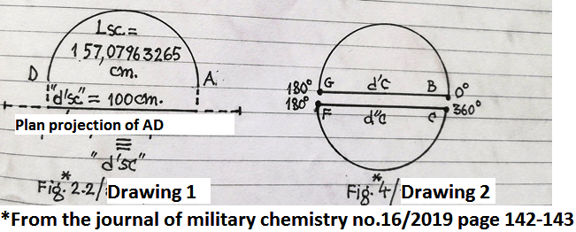

In the study, we reported that: “When projecting a circle in the plane, we are dealing with two overlapping diameters - corresponding to each semicircle - like“ 3D image ”and not by one Fig.4
In order to update the formulas (1; 2) the Lsc / d’sc formula segment must be amplified, in order to give the numerical value of the classic “$π$”;
”$π$”(3,141592653...) ≡ 2(Lsc/d’c) ˅ ${}_{}^{2/}{Lsc/d'c}$ ˅ ${}_{}^{2/}{Lsc∙{d'c}^{-1}}$
Choose the variant that suits the placement in the respective formula.
Updating formulas (1; 2);
  - $\hat{AB}$ = (${}_{}^{2/}{Lsc/d'c∙{90}^{0}/{180}^{0}})Rc \overset{⇒}{}$ Rc =$\hat{AB }∙d'c/Lsc$;
  - $π$v(${}_{}^{2/}{Lsc/d'c∙n^{0}/{180}^{0}}$) = Larc; Lc/Rc.
When “marginalizing” the classic “$π$” symbol, we started from the idea that the novelty aspect of the study is minimized. As such, the classic "$π$" should have only the function of "CONSTANT OF CIRCLES", optional with the symbols "k$π$" or "kC".

TITLE 4. THE FINAL FORMULA OF THE SURFACE AREA WITHOUT "PV" - "PI VARIABLE"
Continuation from 29.06.2020 at - Marginalization of the number "Pi - classic"
29.06.2020*

The continuation was determined by the "scenario" that took place during the "match" of the presidential candidates in the fall of 2019.
In the magazine of Military Chemistry of the Association with the site “acchimrr.ro the company Google; Chrome no. 14th anniversary, May / 2018 on page 160 I inserted, in passing:
"And Sc (surface of the circle) = Pv·Rc² (Formula 1) where in the end," Pv "(variable Pi) = Lsc / Rc (F.2)"
I specified "in passing", since, in the study regarding no. "Pi" and "Pv", I did not intend to detail the new formula, related to the surface of the circle.
So, remembering the images developed in that "dispute", I switched to "Pv" with Lsc/Rc. So, Sc =Lsc·Rc²/Rc which, after the necessary simplification, resulted in the final formula of the Circle Area (F.3) without “Pv”;
Sc= Lsc·Rc - (final formula of sc.)
We know that "Pv" in point "G" of the semicircle BG (Fig. 5 page 161 of the mentioned magazine) has the numerical value of "Pi" - classic; ”Pv”≡”Pi” (3.1415 92 653 ...).
Obviously, this new relationship lends itself easily to finding the surface of the circle, when we know the numerical value of both terms - Lsc and Rc - the calculation being simplified, by the lack at the end, of "Pv" as we mentioned. In order to reach the determination of “Sc” when it is known, for example, the numerical value of “Rc”, we will have to resort to no. "Pv" or at one of the semiconstants of the circle (skC); ”Pv/2” sau ”Pi/2”; Pv/2≡Pi/2 (1,5707 963265).

The question is quite simple, because, in a way, a priori, the numerical values ​​of the terms underlined above, with the related geometric figures, are familiar to us, thus;
a. "Pv" - see page no. 158; 161 of the Association Magazine no. 14 / May 2018 and with Fig. 5 / Plate 1 where, Lsc =”Pv” (3,1415 92653)·Rc;
b. skC ”Pi/2”(1,5707 9632 65) = Lsc/d’c pag. 139; 142 of the Association Magazine no. 16 / May 2019 and with Fig. 2.2
c. skC”Pv/2” - we appeal to the new definition of Rc;
Rc=$\hat{AB}$/0,5∙”Pv” - Association Magazine no. 14 / May 2018 page 156; 161 and with Fig. 3; 4.

Application 1: - Initial data; Rc = 80 cm.
intermediate dates; "Pv" = 3.1415 92653 according to lit. a
Lsc = ?, Sc =?
Express;
  - Lsc = Pv(3,1415 92653)·Rc(80 cm) => Lsc = 251,327 412 24 cm
  - Sc = Lsc(251, 327 412 24 cm) ·Rc(80 cm) => Sc ~ 20.106,193 cmp.

Application 2: - Initial data; Rc = 80 cm => 2Rc=160 cm
intermediate dates; skC”Pi/2” = 1,5707 9632 65 according to lit. b
Lsc = ?, Sc =?
Express;
2.1 Lsc=Pi/2·d’c; Lsc = 1,5707 963 65·160 cm => Lsc~251, 327 412 16 cm.
2.2 Sc= Lsc(251,327 412 16)·Rc(80 cm); => Sc~20106, 193 cmp

Application 3 - Find out this time Rc, then Sc?
We conform to the letter "c";
Initial data; $\hat{AB}$ ~ 125, 664 cm;
”Pv/2” = 1,5707 9632 65
Rc = ?, Sc =?
Express;
3.1 Rc=$\hat{AB}$(125,664 cm) : ”Pv/2”( 1,5707 9632 65) => Rc = 80 cm
3.2 Sc = 2$\hat{AB}$ (251,33 cm) · Rc(80 cm) => Sc ~ 20106, 2 cmp; 2$\hat{AB}$≡Lsc

Application 4 - Verification of the new Formula by the classical relation; Sc=Pi·Rc²
Sc= 3,1415 92 653 · 80 cm² => Sc ~ 20106, 2 cmp.

Specification from 30.06.2020.
From the presented data, it can be deduced that there are two directions to approach the determination no. "Pv" Pi and others - The first direction, I call it static and it is related to no. "Pi" - classic; - In the magazine of the association no. 14/2018 / page 162 I reproduced, I quote: “In the year 1400 the Uzbek scholar Djemsid Ben calculated “Pi”- using a regular polygon with over 800 thousand sides - with 16 decimals; 3.1415 92653 589 7932 surprisingly accurate result; - see also Application 2; - The second direction, I call it, dynamic and is related to no. "Pv" etc. - a Romanian "Pv", which is based on determining the respective numbers, on the circumference of the Circle, this, by sweeping Rc, with the formation at the center of the Circle of an angle, in degrees, minutes, seconds, etc. default, - similar to Applications 1 and 3. Between the two directions, the semiconstant “skC” can be considered as a bridge. "Pi/2" which introduces us, in a way, - why not? in The Theory of Relativity. We know that the semiconstant in question represents the projection in the plane of a semicircle, according to those mentioned above; and two projections in the plan, give the value no. Pi - classic (3.141592 653…). By comparison, in the Theory of Relativity, the wavelength of a particle is practically represented as a sinusoid - to which the relation ”2Pi·r” is applied - both "loops" of the sinusoid being considered to be a circle. According to those specified in certain works, by the Formula of the length of the circle, one can reach the Planck constant; h = 2Pi·1,0545·10⁻³⁴ J/s. In other words, a surprising connection between the visible, real and the invisible, microcosmic world.

Bibliography:
1. E. Pietrăreanu -“Electrician's Agenda” -Technical Publishing House 1979;
2. Măriuca Marcu, Ion Moga -“Elementary Dictionary of Sciences - mathematics, physics, astronomy”-Scientific and encyclopedic edition 1978;
3. A. Barna, M. Oncescu - “Physics of atoms” - Scientific and encyclopedic edition 1978;

NOTE: the first two articles / studies are taken from the Association Magazines, no. 14th anniversary / 2018 and no. 16/2019

DATA*
Legalized studies at B.I. Notary, according to the manuscript,

Computer writing;
D.eng; PhD. Dumitrescu Răzvan-Olimpiu
Translator by Ph.D. Oprică Octavian; D.eng; PhD. Dumitrescu Răzvan-Olimpiu

